**CHAPTER ONE**

**1.0 INTRODUCTION**

**1.1 Background to the study**

Fishing is a traditional activity involving the hunting and gathering of aquatic products for food.Fish and marine products include freshwater and ocean fish, shell fish, ocean mammals, and seaweed as well as planktons. (Ita*et al*1986).,

Fish is as old as man-kind, the oldest way of fish production is the utilization of the existing water bodies which include the sea, oceans, lakes, dams, reservoir, river, stream, flood plain etc. The existing natural water bodies considered for fish production occupies a large area of land, (Ita*et al*., 1986, Shimang, 2005) gave a total surface area of approximately 12.5 million hectares for the existing water rivers, dams, lakes, etc.

Fish production in Nigeria comes from three sources, artisanal (inland river, lakes, coastal and brackish water), aquaculture (fish farms), and industrial fishing (Otubusin, 2011). But the majority of fish supply in most cases comes from the artisanal sub-sector.

However, there are various technology of fish production and capturing used in Nigeria inland water among which are the use of Hooks and line, use of metal and bamboo made trap, gill net, cast net, use of engine to drive sophisticated gears like (draw net) are mainly used in artisanal fisheries among the fishers in Nigeria while large gill nets and trawlers are widely used in industrial fishing, (Otubusin, 2011).

An understanding of the principle of operation of capture and culture fisheries help to throw light on the definition of aquaculture. The expression capture and culture fisheries are self- explanatory, in the former, one reaps the aquatic harvest without having to sow, whereas, in the latter, one has to sow the seed, nurse it, tend it, rear it, and harvest it when it reaches the marketable size. The governments try to improve or increase fish production through aquaculture. Increased fish production through aquaculture was to no avail according to Ajana (1980) who reported that aquaculture is just gaining prominence in Nigeria. Presently its level of development and rate of growth is rather slow, out of about 0.8 million hectare of swamp land in the six coastal states of Nigeria which include Ogun, Ondo, Delta, Lagos, River, and Cross rivers only about 27 hectares (0.003%) is being utilized for fish farming(Ajana, 1980).

The slow growth of aquaculture practice in Nigeria could be attributed to the basic problem of poor knowledge of the biology of the local fish species and their culture, unavailability of fingerlings, also the technology involved in aquaculture practice is not understood by the rural fishers, who are mostly illiterates. Likewise, some of the modern technology techniques of fish production are not used by the farmers either because they are too costly or out of the reach of the farmers. For example, the fuel engine used for fishing boat consumed a lot of fuel and this adds to cost of production to the farmer., As a result of this, the fishers do not utilize these modern techniques of fish production and capturing.

However, the commercial fish farmers who are using this modern technique of fish production has not produce enough fish to meet the populace desire requirement of fishes. Artisanal fishers in rural areas have acquired an amazing detailed traditional (indigenous) knowledge of fish production, fish behavior, and fish reproductive habit, lunar forces, and tides and other oceanography conditions which they have been using over the years and fish production using this knowledge has been profitable to the fishers. In addition, the advantages of indigenous techniques of fish production and capturing over the modern techniques are many as these correct some shortcomings or weakness of the modern techniques due to the fact that the indigenous fish production techniques are easily practices with minimum cost, these techniques are accessible to all fishers both male and female.

The method does not pollute water as fuel from modern engine boat does. No money is spent on fuel, thus reducing production cost of the farmer. Also the local gear for the indigenous techniques of fish production and capturing are made by the farmers from locally available natural forest and local materials.

Many artisanal fisheries along shoreline areas in most places in the world are of the “S” type: Small-scale, Spatial-structured and catching Sedentary stocks (Orensanz*et al*., 2005). It may be a native fishery for sustenance or commercial fishing using indigenous or small-scale fishing gear like nets, traps and also using motorized or non-motorized fishing boat during fishing activities (Mustapha, 2013). Artisanal fisheries use proportionally little amount of monetary capital for fishing activities by covering short distances close to the coastal shore of the water. The harvested fish are sold in their locality and consumed by fisher’s families (Mustapha, 2013).

Like in many other places, artisanal fisheries in Nigeria are characterized by low scientific knowledge, deficiency of modern equipment and modest investment. These usually result into intensivity of labour utilization, and little or no prospect of expansion (Ibrahim *et al*., 2009). Statistics has shown that fish demand exceeds supply (Ibrahim *et al*., (2009). Tsadu*et al.,* (2006) and Ibrahim *et al*., (2009) estimated fish demand in Nigeria to be about 1.3 million metric tons, but the annual fish consumption was estimated to be 2.6 million metric tons (Clement, 2013; Oyakhilomen and Zibah, 2013). The inadequate in fish supply may have transformed to high price of fish (Ita, 1993). Local production of fish is dominated by artisanal fisheries, accounting for almost 85% of total fish productions (Mustapha 2013). In spite of this small scale operation, artisanal fisheries contribute significantly to sustainable livelihoods of people in several ways.

Fishermen who are involved in artisanal fisheries in Nigeria make use of boats and gears made up of both natural and synthetic materials. Fishers use planked canoe, dugout canoe and half dugout canoe for fishing and each of them has different constructional characteristics (Ambrose *et al*., 2001; NIFFR, 2002). The planked canoes are made up of timbers, usually with flat bottom (Solarin, 1998). They are fully constructed with planks joined together with frames, U-shaped metal closures and nailing strip of galvanized iron aluminum pluck caulking over the plank joints (Solarin, 1998).

The dugout canoe which is propelled with paddle, mostly provides minute space to contain fishers, gear and harvested fish during fishing operation. The dugout canoe has quite small free board and thus, shows low reserved buoyancy and less stability in comparison to any other kinds of canoe (Solarin 1998). However, Emmanuel (2010) reviewed that half dugout canoe combines characteristics of planked canoe and dugout canoe. The round bottom body shape of the dugout craft is built up with planks on each side to increase the size or cubic quantity of the canoe.

With regard to propulsion, craft can be operated by paddle or controlled with outboard engine. The attachment of outboard engine to craft in Nigeria has been reported by Udolisa*et al.,* (1994). NIFFR (2002) reported that majority of the craft used in inland water of Nigeria are generally non-motorized, due to high cost of outboard engine.

**1.2 Statement of problem**

Fish production is a major concern in Nigeria, the importance of fish itself and its products in human diet cannot be over emphasized. It is a rich and cheapest source of protein. For Nigeria to excel nutritionally there is need for increase in fish production which is a major source of cheap protein. The modern techniques of fish production used by fish farmers in the urban area (commercial) cannot sustain the protein (from fish) requirement alone and this technique is not practiced by farmers in the rural area either because such techniques are not accessible to them or the techniques are too costly or not compatible with their belief and culture.

However, an intense relationship seems to exist between effort being made by fishers to boost their business and actual outcomes. Also, Aquaculture is gaining more recognition in Nigeria,Therefore, this study intends to investigate the indigenous methods of fish production and capturing in order to ascertain their efficiencies in ensuring an increased and sustainable fish production and in so doing, the following research questions were asked:

* What are the indigenous methods of fish production and capturing?
* Why are these indigenous methods used?
* What are the descriptions of indigenous fishing method used by the fishers?
* How are the fish species caught?
* What are the factors affecting fish production and capturing?
* What are the sources of capital and extension services for the business?

**1.3Objectives of the study**

**1.3.1Broad objective**

The broad objective of the study is to investigate indigenous fishing methods used among fishers in Oyan Lake, Ogun State, Nigeria.

**1.3.2Specific objectives of the study**

To meet the broad objective, the study focused on the following specific objectives

Which were to:-

* describe the socio-economic characteristics of the fishers in the study area
* identify and describe various indigenous methods of fish production and capturing
* examine the perception of fishers about use of indigenous method of fishing in the study area
* identify the species of fish commonly caught in the study area

determine the sources of extension services awareness available for the fisher in the study area.

**1.4Justification**

The purpose of this study is to investigate the various indigenous fishing methods among fisher in Oyan Lake,Ogun State, with emphasis on selected villages in Abeokuta North Local Government Area of the state.It is believed that the outcome of this research work will be of interest to fishers as it will enlighten then on how to improve their outcome.

* This research work will also serve as vital material to those who may want to carry out further research work in these regards.
* Fishers using indigenous method contribute highly to the total fish production of the nation like their counterparts who are using modern techniques in other part of the country, hence this study will also help in increasing fish production in the country.

**1.5 Limitation of the study**

This research Study is limited to Oyan Lake in Abeokuta North local Government Area of Ogun State, Nigeria.These villages includes; Ibaro,Abule-Titun, Apojola, and Imala-Odo.

**1.9 Definition of terms**

**Fish:** Fish is a limbless cold-blooded vertebrate’s animal with gills and fins living wholly in water.

**Fish production:** The total quantity of fish elaborated over a stated period of time regardless of whether or not all of it survives to the end of that time.

**Fishery**: A collective term describing all activities connected with fishes such as cultivation, propagation, harvest, storage, and preservation, processing, marketing, management, etc.

**Fishing:** Fishing is the use of appropriate tools in catching fish

**Substantial fishing**: This is catching of fish for the use of the family with non-really left for sale

**Artisanal fishing:** This is a small-scale fish business that employs the use of flow inexpensive crafts and gears during operations.

**Fish gear**: This is any implement used for catching fish. For example, gill net, cast net, hooks and lines.

**Drift net**: A large net to which weights are attached at the bottom and floats at the top and allowed to drift.

**Fishing efficiency:** The ratio of the number of caught to the number present in the area fished or sampled

**Fishing season/period:**  The time of the year when fishing is carried out

**Gill net:** A fishing net (which can be suspended from the surface by floats and sunk to the bottom by sinkers) which catches fish by the gills.

**Overfishing:** Act of taking more fish than can be replaced through growth and recruitment in a single season.

**CHAPTER TWO**

**2.0 LITERATURE REVIEW**

**2.1 World capture fisheries**

Global capture fisheries production in 2008 was about 90 million tonnes, with an estimated fish-sale of US $93.9 billion, comprising about 80 million tonnes from marine waters and a record 10 million tonnes from inland waters. Table 1 shows that capture fisheries and aquaculture supplied the world with about 148 million tonnes of fish in 2010 (with a total value of US 217.5 billion), of which capture fisheries had the highest number (88.6 million tonnes) when compared with aquaculture production and preliminary data for 2011 indicate increased production of 154 million tonnes, of which capture fisheries still contributed more than aquaculture (FAO, 2012).

The inland fisheries sector is extremely diverse. It involves a wide variety of fishing techniques, ranging from simple hand –held gears to small trawl or purse seines operated by commercial fishing vessels. Inland fisheries include commercial and industrial fisheries, small scale fisheries and recreational fisheries, each with a different economic and social structure. Global inland capture fisheries production was fairly stable between 2000 and 2004 at about 8.6 million tonnes, but in the following years it showed an overall increase of 1.6 tonnes, reaching 10.6 million tonnes in 2008. China remained by far, the global leader (in capture fisheries) with production of about 15 million tones (FAO, 2012).

Inland fisheries are a vital component in the livelihood of the people in many parts, in both developing and developed countries. However, irresponsible fishing practices, habitat loss and degradation, dam construction, drainage of wetlands and pollution (including eutrophication) often act together and have resulted in substantial declines and other changes in inland fishery resources, (FAO, 2012).

**Table 1: World fisheries and aquaculture production (million tonnes)**

|  |  |  |  |  |  |  |
| --- | --- | --- | --- | --- | --- | --- |
| **Years** | **2006** | **2007** | **2008** | **2009** | **2010** | **2011** |
| **Production** |  |  |  |  |  |  |
| **Capture** |  |  |  |  |  |  |
| Inland | 9.8 | 10.0 | 10.2 | 10.4 | 11.2 | 11.5 |
| Marine | 80.2 | 80.4 | 79.5 | 79.2 | 77.4 | 78.9 |
| **Total capture** | 90.0 | 90.3 | 89.7 | 89.6 | 88.6 | 90.4 |
| **Aquaculture** |  |  |  |  |  |  |
| Inland | 31.3 | 33.4 | 36.0 | 38.1 | 41.7 | 44.3 |
| Marine | 16.0 | 16.6 | 16.9 | 17.6 | 18.1 | 19.3 |
| **Total aquaculture** | 47.3 | 49.9 | 52.9 | 55.7 | 59.9 | 63.6 |
| **Total world fisheries** | 137.3 | 140.2 | 142.6 | 145.3 | 148.5 | 154.0 |

**Source:** FAO, 2012

**2.2 Fish production in Nigeria**

In Nigeria, only fish contributes on average, 20-25% per caput animal intake and could be as high as 80% in the coastal and riverside communities (FAO, 2000). (Ajana, 2002) reported that the average annual demand for fish in Nigeria between 1995 and 2002 was estimated at 1.22 million metric tonnes by the year 2005. (FAO, 2000) estimated the projected population and fish demand/supply from 1997 to 2025, with domestic fish production by the year 2007 as 0.77 million tonnes. According to Fish Report 2006, Nigeria has become a major destination for imported seafood since the time the government of Nigeria made a tariff reduction on all fishery products in 2001 from 25% to 5%. Now, the aquaculture and fisheries industry is probably the fastest growing food producing sector and now accounts for 50% of the world’s fish that is used for food (FAO, 2016).

**2.3 Nigeria fisheries and aquaculture production**

Nigeria with a population of approximately 140.7 million and 3.2% annual growth rate (2006 census) is multi-ethnic. Despite the abundance fisheries resources and the relatively high consumption of fish in Nigeria that is the largest simple consumer of fish products in Africa (FDF, 2005; 2008), its domestic output of 0.62 million metric tonnes still falls short of demand of 2.66 million metric tonnes (FDF, 2008). A supply of deficit of 2.04 million metric tonnes is required to meet the ever-increasing demand for fish in Nigeria. This large deficit between the demand and supply of fish is augmented by massive importation of frozen fish and consequently effect on the exchange earnings of the national economy as well as caput consumption 9.68kg/head/year (FDF, 2008). The species imported are mainly herring, mackerel and stock-fish to offset the deficit of 2.04 million metric tonnes. Quantity of fish imported rose from 557,884.00 tonnes to 739,666.12 tonnes between 2000 and 2009.

**Nigeria spent N100 billion on importation of frozen fish in 2010 while the current fish demand is 2.6 million tonnes per annum**as against the annual domestic production of about 0.78 million tonnes, giving a demand-supply gap of about 1.8 million metric tonnes (CBN, 2012). The local supply consists of productions from the artisanal (418,069 – 668,754), industrial (23,308 – 45,631), and aquaculture (25,720 – 253,893) sub-sectors (Federal Ministry of Agriculture and Rural Development, Fisheries Department, 2013). However, it has been shown that Nigeria can substitute fish importation with domestic production to create jobs, reduce poverty in rural and peri-urban areas where 70% of the population live and ease the balance of payment deficits (Areola, 2007; FDF, 2005; Olaoye, 2010).

**2.4 Fish supply-demand projection**

Nigeria’s demand for fish in 2010 was projected at 1.89 million MTs in Table 2. However, actual production was 800,000 MTs as shown in Figure. 1. The fish supply gap deficit was over 1 million MTs.Considering that the population growth rate of Nigeria is 3 %, the fish supply gap deficit is expected to continuously increase.Current globalaverage annual consumptionis about 16.0kg/yralthough it is 13.5 kg/yrin Table 2. If the Nigeria targets the amount, the total demand will be 20% more than the forecasted demand. The gap will be some 2 million MTs.

**Table 2: Fish supply-demandprojection (2000-2015).**

|  |  |  |  |  |  |
| --- | --- | --- | --- | --- | --- |
| **Year** | **Projected population**  **(million)** | **Per capital consumption**  **(kg)** | **Projected fish demand (t)** | **Projected domestic fish production (t)** | **Fish supply gap deficit (t)** |
| 2000 | 114.4 | 13.5 | 1,430,000 | 467,098 | 962,902 |
| 2001 | 117.6 | 13.5 | 1,470,000 | 480,164 | 989,836 |
| 2002 | 121.0 | 13.5 | 1,512,500 | 507,928 | 1,004,572 |
| 2003 | 124.4 | 13.5 | 1,555,000 | 522,627 | 1,032,373 |
| 2004 | 128.0 | 13.5 | 1,600,000 | 536,918 | 1,063,082 |
| 2005 | 131.5 | 13.5 | 1,643,750 | 552,433 | 1,091,317 |
| 2006 | 135.3 | 13.5 | 1,691,250 | 567,449 | 1,123,301 |
| 2007 | 139.1 | 13.5 | 1,738,750 | 583,872 | 1,154,878 |
| 2008 | 143.0 | 13.5 | 1,787,500 | 600,613 | 1,186,887 |
| 2009 | 147.1 | 13.5 | 1,838,750 | 617,353 | 1,221,397 |
| 2010 | 151.2 | 13.5 | 1,890,000 | 634,560 | 1,255,440 |
| 2011 | 155.5 | 13.5 | 1,943,750 | 652,606 | 1,292,143 |
| 2012 | 160.0 | 13.5 | 2,000,000 | 671,492 | 1,328,508 |
| 2013 | 164.4 | 13.5 | 2,055,000 | 689,958 | 1,365,042 |
| 2014 | 169.1 | 13.5 | 2,113,750 | 709,683 | 1,404,067 |
| 2015 | 174.0 | 13.5 | 2,175,000 | 730,248 | 1,444,752 |

**Source; FAO, 2015**



**Figure 1: FAO, 2010**

**2.5 Fish demand and supply in Nigeria**

Going by the 2013 estimates, Nigeria has a population of over one hundred million people currently has her national fish demand at 2.7 million metric tonnes, supply at 0.8 million metric tonnes, leading deficit of 1.9 million metric tonnes. Over the years, the demand for fish has always exceeded the supply. It has been projected that the deficit would continue to increase. The seriousness of the shortfall between demand and supply for a commodity that used to be the cheapest source of animal protein available to the people is obvious and the cells for concerted effort to narrow the gap to forestall widespread malnutrition. With an extensive coastline of 853 km and wall over 14million hectares of inland waters the country has the resource capacity to meet its own fish demand as well as export.

Nigeria spends N100 billion on fish importation annually and the current fish demand consumption in Nigeria stands at over 2.66 million tonnes per annum, while the present importation rate is over 750,000 metric tonnes (Oota, 2012). With importation of more than 750,000 MT of fish, more than USD 600 million are spent in hard currency and thousands of jobs are exported (USAID, 2010). The continuous importation of fish portends a colossal loss of foreign exchange earnings to Nigeria. In order to bridge the demand-supply gap, an aquaculture transformation agenda plans to increase annual fish production from the current production of 0.78 million MT to 3.0 million tonnes in order to achieve self- sufficiency in fish production and supply by the year 2015 (Tijani, 2011). This will be achieved through fish farm development program, fish seeds and feed mill development program, fish pen and cage culture development program and fish post-harvest management and marketing program.

|  |  |  |
| --- | --- | --- |
|  |  |  |

**2.6. Fish productivity**

**2.6.1 Genesis of artisanal fishing**

Artisanal fishing is the hunting of self-reproducing stocks of wildfish in a very harsh environment over which man has almost no control(Gorden, 1993). According to Williams (1995), it is the finding andcapturing of wild species of fish that the fisherman cannot see in vast andlargely barren areas of rivers, lakes and streams. Harvesting water productsby diving in deeper waters, wading in shallow waters without the help ofboats, tools and only using simple gears or hands have been known for millions of years to the present day (Coul, 1983; FAO, 2002).

The fundamental understanding by fishermen the behavior of fish, enables them to outwit the fish and catch it even with simple gear. Thisknowledge of fish behavior according to FAO (1993) is falling fast into oblivion as a result of emergence ofmany sophisticated machines to operate fishing gears automatically and thedevelopment of electronic equipment’s for searching and finding fish inwater.

**2.6.2 Artisanal capture fisheries versus fish culture**

In contrast to capture fisheries where the wild stocks of fish areharvested, fish culture or aquaculture is an underwater agriculturalproduction of fish species in which production cycles, breeding, feeding, stocking and protection is virtually controlled by human (Tobor, 1990).

Most international development agencies classify these two types of fisheries together as common fisheries sector.The harvesting of fish culture products is controlled and the productis predictable where as in capture fisheries, the prey is wild therefore fishers move from place to place where there is an element of riskinvolved. On manpower and capital requirements, capture fishermen needonly to harvest what grows naturally and in small-scale. This is done withrelatively low capital investment. In contrast, fish culture system canrequire both cultivation and harvesting which depend on more complexfinancial investments (Soyinka*et al* 2008).

**2.7 Techniques of fish production and capturing**

There is lots of fishing water bodies in Nigeria. Examples include Argungu fishing water in Sokoto, Ayetoro/IgbokodaIlaje- EseOdo and Epe fishing waters. Fishing is also carried out in fresh water bodies like the rivers, streams, lakes and ponds.In all these water bodies, the methods employed for catching fishes are broadly divided into two - the indigenous (crude) methods/techniques; and the modern techniques

**2.7.1 Indigenous fishing techniques**

These methods are also referred to as the traditional or primitive methods. They are methods used in catching fishes in the ancient traditional olden days. The techniques involved:

**Fishing with screens**:Screens can be made of bamboo or palm fronds and are oftenused in shallow tidal creeks and estuaries to form encloses which are arranged in such a way as to allow the entry of fish or crayfish and disallow their escape. Fish are trapped in when the water goes down and are fished out at low tide using gears like scoop or trap nets.

**Fishing with gears**: This involves the collection of aquatic organisms that are sessile or not very mobile using wounding gears. These wounding gears include spears, cutlasses, knives, hooks and lines, primitive nets.

**2.7.2 Effects of indigenous techniques**

Indigenous method was the main fishing techniques used by traditional or local fishermen in catching their fishes from the water. However, both the technique and the fishing gears employed pose some hazards to the fishes, the aquatic environment and the society at large.

Obnoxious methods of fishing like use of gamalin 20, Didimore 25and poisonous leave, roots and fruits of some toxic plants cause water pollution thereby making the water unsafe for human use. Consumption of fishes killed by poison also has lethal effects on the consumers. By eating poisoned fish, the poison or toxic is directly or indirectly transferred to the consumer which if adequate medical care is not taken, vital organs may be damaged and may eventually result in death. A pregnant woman that takes poisoned fish faces the likelihood of the unborn suffering from some congenital abnormalities. Also, poisoned water is very unsafe for drinking or for other domestic uses. The use of poisoned river for irrigation to agricultural farmlands also poses a potent environmental danger to the agricultural crops and the farmland. The use of hooks, spears, cutlasses inflicts physical damage on the fishes and this accelerates the rate of decay of the fishes as a result of bacterial invasion on the damage parts.

The volume of catch is also reduced by the use of hook and line method. It is also time-consuming as fishermen have to spend a longtime on boat only to catch few fishes. The use of local fish nets whose mesh sizes are not regulated or nets with undersized meshes poses dangers for small young fishes especially the fingerlings, which may likely be scooped out of water prematurely (FDF,2003).

**2.7.3 Modern fishing techniques**

These are methods used in this present-day world. They include the use of elaborate nets like the gill nets, bay nets, cast nets, drift nets, surrounding nets. Sophisticated equipment are also being used. These include motor propelled equipment which are now used for commercial fishing Diesel marine engine, trawlers and ships are purposely built and used for fishing voyages for 2-3 days and for preserving catches (Ayoola*et al*, 2009).

**2.7.4Effects of modern techniques**

This method involves the use sophisticated modern equipment asfishing gears. It includes the use of fishing nets with regulated mesh sizes, motor propelled machines, diesel marine engines, trawlers andships for commercial fishing.

With the use of these modern fishing equipment

i. More catch is registered at faster rate.

ii. The fishes caught are safe for human consumption.

iii. The purity or quality of water is not affected since the water isnot polluted. Thus the water is safe for drinking and for other domesticuses.

iv. Fishes can be stored for longer period and well preserved inmobile refrigerator fishing vessels.

**2.8 Contribution of artisanal fishing to fisheries production in Nigeria**

Nigeria does not produce the total fish needed by her populations.As far back as 1978, Sagua*et al*.(1978) / that local fish production could only supply about 700,000 metric tonne per annum leaving a deficit of 30%. This situation has not changed even as Nigeria enters into the 21st century. Inspite of the ambitious hope for fish production from the countries reservoirs, dams, perennial rivers and saline mangrove swamps fish as an affordable protein source still eludes the greater part of the population. Nigeria has consistently fallen markedly below the FAO's recommendation of daily minimum protein intake of 70grams of which 35grams should come from animal sources. Rations of children in all part of the country are deficient in protein and calories to the tune of over 25% and 15% respectively(Akegbejo-Samsons, 1997).

Even though Nigeria's inshore and offshore waters were open to all eligible fisher that are using that modern method of fishing, the cost of fishing, the cost of fishing efforts and stripes do not match the total revenue expected. It now beholds on us to intensify the various indigenous management techniques used by the fish farmers in the local areas to increase fish production in Nigeria just as indigenous methods of seed selection and preservation was used to increase food crops in Andaman Island in India.

**3.0 METHODOLOGY**

**3.1 Area of study**

**3.2 Oyan Lake**

Oyan Lake is a major tributary to the West of Ogun River. It is located 070 58'N and 03° 02'E with a catchments area of 1610km2. The dam is situated some twenty kilometers North West of Ogun-Osun River Basin Development Authority (OORBDA) Alabata Road, Abeokuta. The dam, which was constructed in 1979, and commissioned in 1983 covers an area of 40km2, with a maximum depth of 63m. The lake has a length of 27km with a maximum width of 6km (Ikenweiwe*et al*., 2007).

The dam was primarily built to provide hydroelectric power, and provide water for domestic and industrial uses around Abeokuta and Lagos environs. It was also meant to supply water for irrigated project of about 3,000 ha and to provide fishing ground for the adjoining communities. Fishing is the main activity of the people around the Lake area while some of the fishing villages include Ilakan, Akiro, Abule-Titun, Apojola,Imala-Odo, lbaro villages as shown in Figure 2 (Ikenweiwe*etal*., 2007).

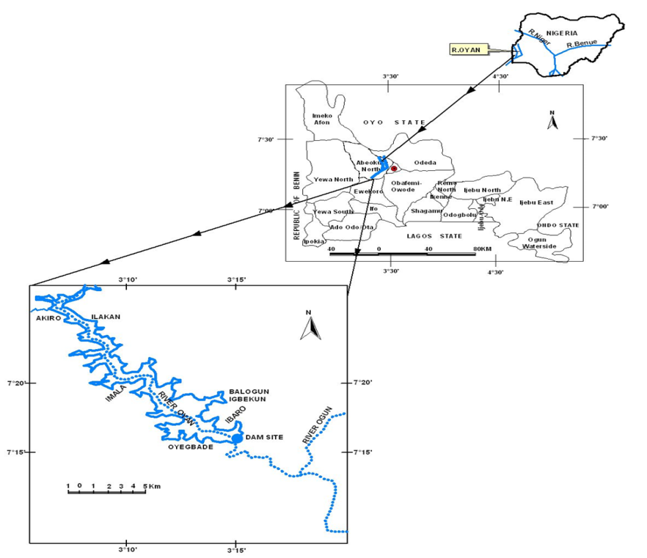

Figure 2: Map of Oyan Lake in Ogun State

Source; Ikenweiwe*et al*., 2007

**3.3 The population of the study**

The study population consists of fisher in fishing villages around Oyan Lake, Abeokuta North Local Government Area of Ogun State. The villages are;

1 Imala-Odo

2 Apojola

3 Abule-titun

4 Ibaro

**3.4 Sampling Procedure and Sample Size**

A two-stage sampling procedure was used in sampling 120 fisher for this study as described below. The first stage involved the purposive selection of four fishing villages out of eight registered villages due to their proximity to Oyan Lake as well as their level of involvement in the use of traditional methods of fishing. This was followed by a random sampling of 60% of the fisher in each of the selected villages to give a total of one hundred and twenty (120) out of the two hundred (200) fisher obtained from the list of licensed fishers with the assistance of extension personnel in the different villages. The breakdown of the sample size from the different villages is as shown in Table 3.

Table 3: Sampling procedures and sample size

|  |  |  |
| --- | --- | --- |
| Fishing villages | Total licensed fishers | Number of interviewed fishers(60% of total licensed fishers) |
| Abule- Titun | 20 | 12 |
| Ibaro | 40 | 24 |
| Apojola | 60 | 36 |
| Imala-Odo | 80 | 48 |
| Total | 200 | 120 |

**3.5 Source of Data**

Data for this study were from the primary sources through the use of semi-structured interview guide to collect quantitative data types and checklist in obtaining qualitative data.

**3.6 Data collection procedure**

The interview guide was used to collect quantitative data from the 120 fishers in the four fishing villages while checklist was used to obtain information from 20 experienced fishers in the use of indigenous fishing methods. The interview guide consists of four sections A – D. Section A was on the socio-economic characteristics (Age, Sex, Religion, Educational attainment, Household size, Fishing experience, Occupations and Membership of social associations) of the fishers, Section B was on the fish species caught by the fishers. Section C was on the fishers’ perception of indigenous fishing methods while Section D was on the fishers’ contact with extension services. The checklist however consisted of two sections with Section A being on the identification of indigenous fishing methods commonly used in each community while Section B was on brief description of the commonly used indigenous methods in the community. The checklist was administered to 5 key informants (community members who are highly experienced in the use of indigenous fishing methods and has attained the age of 50 years and above) through in-depth interviews. Their responses were recorded and pictures of the commonly used indigenous fishing gears were also taken. Data were collected with the guidance of extension personnel and trained research assistants.

**3.7 Validity of research instrument**

Validity of the research instrument was ensured by subjecting the interview guide to face and content validity clarity and purposefulness by the judgment of the supervisors and other experts in related fields.

**3.8 Reliability of the instrument**

The reliability test was done through the test-retest method in which the research instruments were administered to some selected respondents within the spate of two weeks in order to ascertain the consistency of results obtainable from several administered instruments (Olaoye, 2010). Each scale of the research instrument has reliability coefficients of at least 0.75 and hence are considered appropriate for the study.

**3.9 Analysis of Data**

The interview guide was checked for missing data and the data were coded and entered into the Statistical Package for Social Sciences (SPSS) for analysis. Descriptive (frequency, percentage, mean, mode and standard deviation) and inferential statistics were then used to analyze the data. The results were then presented in distribution tables, charts and graphs.

**3.9.1 Measurement of variable**

The variables under investigation were measured as follows;

Independent variables

**3.9.2 Socio- economic Characteristics of the Respondents**

In order to determine the socio-economic characteristic of the fishers questions were asked with respect to:

i. Actual age: was measured at interval level by obtaining the specific age of the respondents and categories in ranges as follows: less than 20 years, 21-30 years, 31-40 years, 41-50 years, and >60 years

ii. Sex: was assessed at nominal level as male = 1 and female = 2

iii. Marital status: was measured at nominal level and respondents were categorized into single = 1, married = 2, divorced = 3, and widow = 4.

iv. Educational level: measured at ordinal level by indication of level of education attained and the respondents were categorized into: No formal education = 1, Primary education= 2, Secondary education = 3, Tertiary education = , and Tertiary school uncompleted = 4.

v. Religion: was measured at nominal level as Christian = 1, Islam = 2, and Traditional = 3

vi. Household size: this was measured at interval level by indication of the specific number of persons living and feeding under the same roof and categorized in ranges.

vii. Membership of cooperatives societies: measured at nominal level and respondents were asked to answer Yes = 2, No = 1.

Viii. Awareness of fisheries extension services; measured at nominal level and respondents were asked to answer Yes =1, No =2.

Vix. The perception of fisher about the use of indigenous method; was assessed using the statements which were rated as follows; Strongly Agree=5, Agree=4, Undecided=3, Disagree=2, Strongly Disagree=1 and reversed for negative statements during analysis.

**CHAPTER FOUR**

**4.0 RESULTS**

**4.1 Socioeconomic characteristics of the respondents**

**4.1.1 Age distribution (year)**

Table 4 shows that close to half (49.2%) of the fishers fell within the age group of 31-40 years, 20.1% were within the 41-50 years, 15.7% were within the age 21-30 years,4.9% were between 10-20 years while 9.8% were older than 50 years. The mean age of the fishers was 38.18±9.829 years.

**Table 4: Distribution of fishers by age**

|  |  |  |  |
| --- | --- | --- | --- |
| **Age (years)** | **Frequency** | **Percentage** | **Mean±SD** |
| >20 | 6 | 4.9 |  |
| 21-30 | 19 | 15.7 | 38.18±9.83 years |
| 31-40 | 59 | 49.2 |  |
| 41-50 | 24 | 20.1 |  |
| >50 | 12 | 9.8 |  |
| **Total** | **120** | **100.0** |  |

SD = Standard deviation

Source: Field survey, 2017

**4.1.2 Sex**

It was gathered that majority (89.2%) of the respondents were male while the remaining (10.8%) were female as shown in Table 5.

**Table 5: Sex distribution of the Respondents**

|  |  |  |
| --- | --- | --- |
| **Sex** | **Frequency** | **Percentage** |
| Male | 107 | 89.2 |
| Female | 13 | 10.8 |
| **Total** | **120** | **100.0** |

Source: Field survey,2017

**4.1.3 Marital Status**

As found in Table 6, close to ninety per cent of the respondents were married, while 9.2% and 1.6% were single and widow respectively.

**Table 6: Distribution of fisher by marital status**

|  |  |  |
| --- | --- | --- |
| **Marital Status** | **Frequency** | **Percentage** |
| Single | 11 | 9.2 |
| Married | 107 | 89.2 |
| Divorced | 0 | 0.0 |
| Widow | 2 | 1.6 |
| **Total** | **120** | **100.0** |

Source: Field Survey, 2017

**4.1.4 Household Size**

Table 7 shows that 71.0% of the respondents have a household size of 6-10 persons, 25.5% have more than 10 persons, while 11.7% have 1-5 persons. The mean household size of the fishers was approximately 9 persons.

**Table 7: Household size distribution of the fisher**

|  |  |  |  |
| --- | --- | --- | --- |
| **Household size** | **Frequency** | **Percentage** | **Mean±SD** |
| 1-5 | 14 | 11.7 |  |
| 6-10 | 68 | 71.0 | 8.62±3.616 persons |
| >10 | 38 | 31.7 |  |
| **Total** | **120** | **100.0** |  |

Source: Field Survey,2017

**4.1.5 Tribe**

As shown in Table 8, the highest proportion (43.3%) of the sampled fisher43.3% were Yoruba, 32.5% were Hausa, while 24.2% were from other tribes such as Idoma, Agatu and the Togolese.

**Table 8: Distribution of the fisher by tribe**

|  |  |  |
| --- | --- | --- |
| **Tribe** | **Frequency** | **Percentage** |
| Ibo | 0 | 0.0 |
| Hausa | 39 | 32.5 |
| Yoruba | 52 | 43.3 |
| Others (Idoma, Agatu and Togolese) | 29 | 24.2 |
| **Total** | **120** | **100** |

Source: Field Survey,2017

**4.1.6 Educational Level**

As presented in Table 9, about three-fifths (59.2%)of the fishers had primary education, and close to one-quarter (24.2%) had no formal education while 12.5% and 4.2% had secondary and tertiary education respectively.

**Table 9: Distribution of fishers by their educational level**

|  |  |  |
| --- | --- | --- |
| **Level of education** | **Frequency** | **Percentage** |
| No formal education | 29 | 24.2 |
| Primary education | 71 | 59.2 |
| Secondary education | 15 | 12.5 |
| Tertiary education | 5 | 4.2 |
| **Total** | **120** | **100.0** |

Source: Field Survey,2017

**4.1.7 Religion**

Out of the sampled fisher, Table 10 reveals that 55.0% practiced Islam, 41.7% practiced Christianity, while the remaining (3.2%)practiced the Traditional religion.

**Table10: Distribution of the fisher by religion**

|  |  |  |
| --- | --- | --- |
| **Religion** | **Frequency** | **Percentage** |
| Christianity | 50 | 41.7 |
| Islam | 66 | 55.0 |
| Traditional | 4 | 3.3 |
| **Total** | **120** | **100.0** |

Source: Field Survey,2017

**4.1.8 Fishing Experience**

The result shows that more than half (55.0%) of the fishers had 11-20 years of fishing experience, 23.4% had spent 1-10 years, while 16.6% and 5.0% had spent 21-30 years and more than 30 years respectively in fishing.

**Table 11: Showed the percentage distribution of fisher fishing experience.**

|  |  |  |  |
| --- | --- | --- | --- |
| **Fishing experience (years)** | **Frequency** | **Percentage** | **Mean±SD** |
| 1-10 | 28 | 23.4 |  |
| 11-20 | 66 | 55.0 | 16.04±7.875 years |
| 21-30 | 20 | 16.6 |  |
| >30 | 6 | 5.0 |  |
| **Total** | **120** | **100.0** |  |

Source; Field Survey, 2017

**4.1.9 Secondary Occupation**

Figure 3 reveals that 45.0% and 37.5% of the fishers had farming and petty trading as their secondary occupations respectively. The remaining fishers were into gear construction, (7.5%), charcoal production (5.6%) and teaching (5.6%).

**Figure 3: Percentage distribution of fishers by primary occupation**

Source: Field survey, 2017

**4.2.0 Membership of cooperative society**

Figure 4 shows that majority (84.2%) of the fishers were members of at least a cooperative society, while 15.8% belonged to no cooperative society.

**Figure 4: Percentage distribution of fishers by membership of cooperative society**

Source: Field survey, 2017

**4.2.1 Revenue per trip**

The revenue of the fishers per trip is represented in the pie chart shown in Figure 5. It shows that 59.1% of the respondents earned between N4000 andN6000 per trip, 33.4% earnedN1000-N3000, while 7.5% earned more than N6000 per trip. The average revenue per trip by the fishers was 3704.17±1520.581.

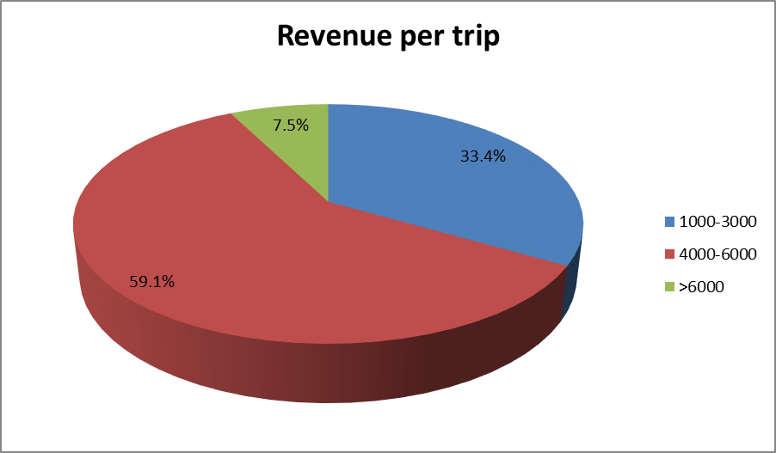

**Figure 5: Percentage distribution of fishers by revenue per trip**

Source: Field survey, 2017

**4.2.2 Awareness of fisheries extension services**

Figure 6 shows that majority (93%) of the respondents were aware of fisheries extension agents

**Figure 6: Percentage distribution of fishers’ awareness of fisheries extension service**

Source; Field Survey, 2017

**4.2.3 Source of awareness of Extension Agent**

Figure 7 shows that the highest proportions (43.3%) of the fishers were aware of fisheries extension service through visits by extension agents, Radio, fellow fishermen, television and print media were the sources of awareness of fisheries extension service to25.8%, 14.2%, 10.0% and 6.7% of the fishers.

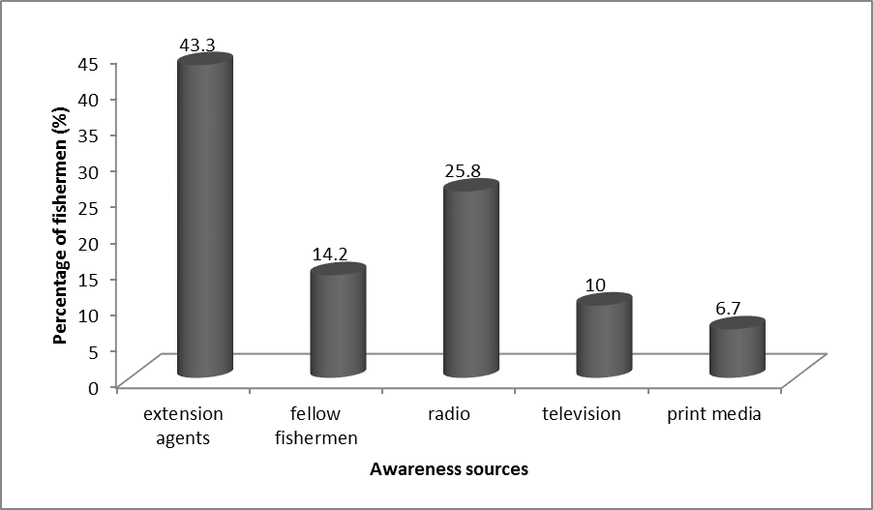

**Figure 7: Percentage distribution of the fishers by sources of awareness of fisheries extension service**

Source: Field survey, 2017

**4.2.4 Visitation by extension agents**

Figure 8 shows that 65.0% of the fishers who were aware of extension fisheries service were visited by extension agents on quarterly basis while 25.0% of them were visited on fortnight basis.

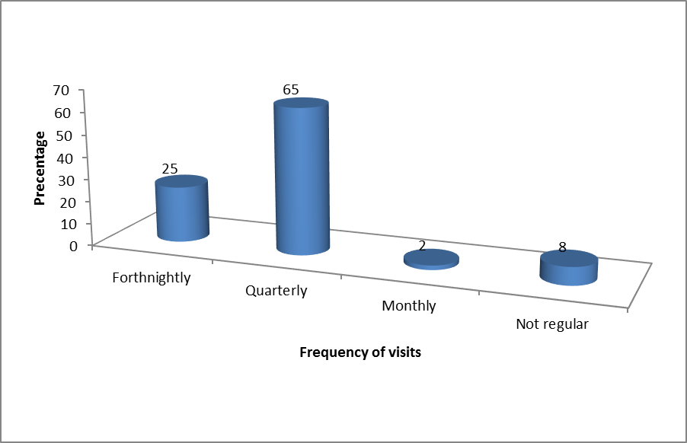

**Figure 8: Percentage distribution of fishers by frequency of extension visits**

Source: Field survey, 2017

**4.2.5 Identification of Indigenous Methods**

Table 12 reveals that hand picking, dewatering and fishing with spears were fishing methods used in the olden days by fishers in all the fishing communities while fishing with bamboo, hook and line, traps, basket trap ‘*Ebiri*’, and Gura trap were still in use in the four fishing communities. Hand netting is still in use among fishers in Apojola, Imala-Odo and Ibaro villages but not in Abule-Titun while digging an enclosure is still in use by fishers in Imala-Odo, Ibaro and Abule-Titun but not in use in Apojola village.

**Table 12: Status of indigenous methods used in the different fishing villages**

|  |  |  |  |  |  |
| --- | --- | --- | --- | --- | --- |
| **s/no** | **Fishing methods** | **Apojola** | **Imala-odo** | **Ibaro** | **Abule-Titun** |
| 1 | Hand picking | 1 | 1 | 1 | 1 |
| 2 | Dewatering | 1 | 1 | 1 | 1 |
| 3 | Fishing with bamboo | 2 | 2 | 2 | 2 |
| 4 | Fishing with hook and line | 2 | 2 | 2 | 2 |
| 5 | Traps | 2 | 2 | 2 | 2 |
| 6 | Fishing with cutlass | 3 | 3 | 3 | 3 |
| 7 | Obnoxious method (e.g poison) | 3 | 3 | 3 | 3 |
| 8 | Fishing with spears | 1 | 1 | 1 | 1 |
| 9 | Basket trap “*Ebiri*” | 2 | 2 | 2 | 2 |
| 10 | Gura Trap | 2 | 2 | 2 | 2 |
| 11 | Hand netting | 2 | 2 | 2 | 3 |
| 12 | Digging an Enclosure | 3 | 2 | 2 | 2 |

Keywords: 1 = used in olden days, 2 = still in use and 3 = not in use

Source: Field survey, 2017

**4.2.6 Fish species commonly caught**

Tilapia species were the most commonly caught species in Oyanlake with 31.7%, while the list species caught were *Latesniloticus*which accounted for 9.2%.

**Table 13: Fish species commonly caught in Oyan Lake**

|  |  |  |  |
| --- | --- | --- | --- |
| **Scientific Name** | **Local Name** | **Frequency** | **Percentage** |
| *Tilapia species* | Epiya | 38 | 31.7 |
| *Clariasgariepinus* | Aro | 18 | 15 |
| *Chrysichthynigrodigitatus* | Obokun | 25 | 20.8 |
| *Latesniloticus* | Aika | 11 | 9.2 |
| *Heterotisniloticus* | Aika-Odo | 13 | 10.8 |
| *Hydrocynusvitttatus* | Tiger fish | 15 | 12.5 |
| **Total** |  | **120** | **100** |

Source; Field Survey, 2017

**4.2.7 Old and new species of fish found in Oyan Lake**

Table 14 reveals the old species of fish that are no longer available in large quantity and the species of fish that is newly introduced.

**Table 14 Oldand new fish species in Oyan Lake**

|  |  |  |
| --- | --- | --- |
| **Name** | **Old**  **Freq %** | **New**  **Freq %** |
| Chinnaobscura | 120 (100) |  |
| Red Tilapia |  | 120 (100) |

Source: Field Survey, 2017

**4.2.6 Perception of fisher about use of indigenous fishing methods**

Table 15 reveals that almost all the fishers (99.2%) were in agreement that the use of indigenous fishing methods led to indiscriminate fishing of fishes irrespective of size and age. Majority (98.3%) of the fishers were also in agreement that indigenous fishing methods are simple to use. It can be deduced that 53.8% of the respondents strongly agree the statement one (1) in Table 15 45.5% agreed with the statement. 85.8% strongly agreed with statement two (2) and12.5% agreed. 85.8% strongly disagreed the statement three (3), while 10% neither agreed nor disagreed. 59.2% and 27.5% were neither agreed nor disagreed and strongly disagreed to statement forth (4) respectively. According to result, 60.8% of the respondents were neither agreed nor disagree and 25.8% Agreed to statement five (5), 55.0% of the fisher strongly disagreed the statement six (6) and 36.7% were undecided, 85.0% and 10.8% of the fisher strongly agreed to statement seven (7). From result, statement eight (8) had 70% undecided while 10.8 disagreed with the statement, 53.3% agreed with statement nine (9) while 88 3% strongly agreed with statement ten (10).

**Table 15: Fisher’ perception of indigenous fishing methods**

|  |  |  |  |  |  |  |
| --- | --- | --- | --- | --- | --- | --- |
| **Perception statements** | **SA** | **A** | **U** | **D** | **SD** | **Mean** |
| **Freq(%)** | **Freq (%)** | **Freq (%)** | **Freq (%)** | **Freq (%)** |  |
| 1.The use of indigenous fishing methods led to indiscriminate fishing of fishes irrespective of size and age | 64 (53.8) | 55 (45.8) | 0 (0.0) | 0 (0.0) | 1(0.8) | 108.2 |
| 2.Indigenous fishing methods are simpler to use | 103 (85.8) | 15 (12.5) | 0 (0.0) | 0 (0.0) | 2(1.7) | 115.8 |
| 3.Indigenous fishing methods lead to pollution of water bodies | 14 (11.7) | 0 (0.0) | 103(85.8) | 0 (0.0) | 3 (2.5) | 67.6 |
| 4. The use of indigenous methods had led to the depletion of aquatic organisms in the lagoons | 1 (0.8) | 0 (0.0) | 15 (12.5) | 71 (59.2) | 33 (27.5) | 98.8 |
| 5. Indigenous methods do not ensure the continuous capture of fish | 0(0.0) | 31 (25.8) | 73 (60.8) | 14(11.7) | 1 (0.8) | 68.4 |
| 6.The fishing output from the indigenous methods are higher than those obtained from the modern fishing techniques | 1 (0.8) | 1 (0.8) | 8 (6.7) | 44 (36.7) | 66 (55) | 97.8 |
| 7.Indigenous fishing methods are cheaper to acquire | 102 (85) | 13 (10.8) | 0 (0.0) | 2 (1.7) | 3 (2.5) | 113.8 |
| 8.Indigenous fishing methods are better for capturing specific fish size and age | 4 (3.3) | 8 (6.7) | 84 (70.0) | 13 (10.8) | 11 (9.2) | 68.2 |
| 9.The use of Indigenous fishing methods poses no health hazards to the fishermen | 6 (5.0) | 64 (53.3) | 6 (5.0) | 34 (28.3) | 10 (8.3) | 76.4 |
| 10. The indigenous fishing methods are easy to maintain and repair | 106 (88.3) | 14 (11.7) | 0 (0.0) | 0 (0.0) | 0 (0.0) | 117.2 |

SA = Strongly Agree, A = Agree, U = Undecided, D = Disagree, SD = Strongly Disagree

Source: Field survey, 2017

Almost all (99.2%) of the fishers had favorable perception of the use of indigenous fishing methods while only 0.8% of the fishers had unfavorable perception of the use of indigenous fishing methods.

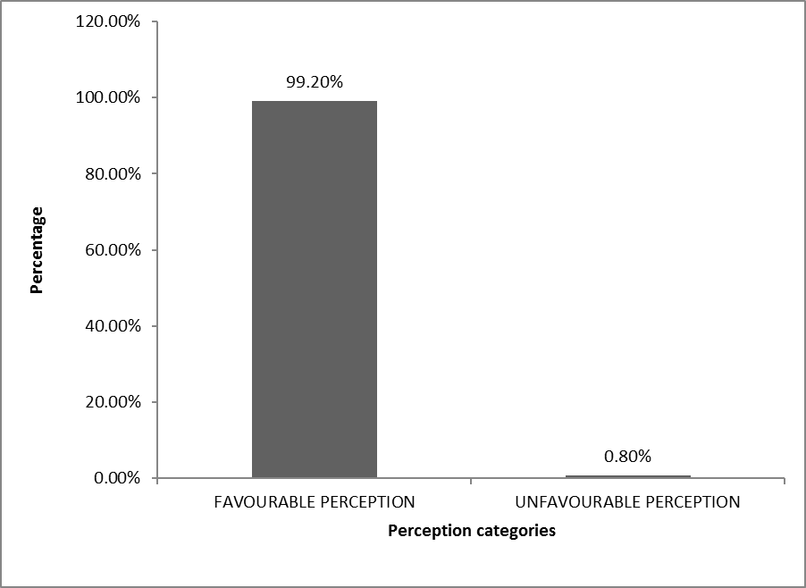

**Figure 9: Fisher’ perception categories of indigenous fishing methods**

**4.2.7 Description of the Indigenous Methods used by Fishermen in Oyan Lake**

**Wire trap**

This trap is made of wire mesh in a triangular form with a hole here fish can enter through without an exit; two pegs are used to hold the trap firmly in water to avoid pending which may lead to fish escape. It is mostly used in Imala-Odo fishing village especially during dry season.

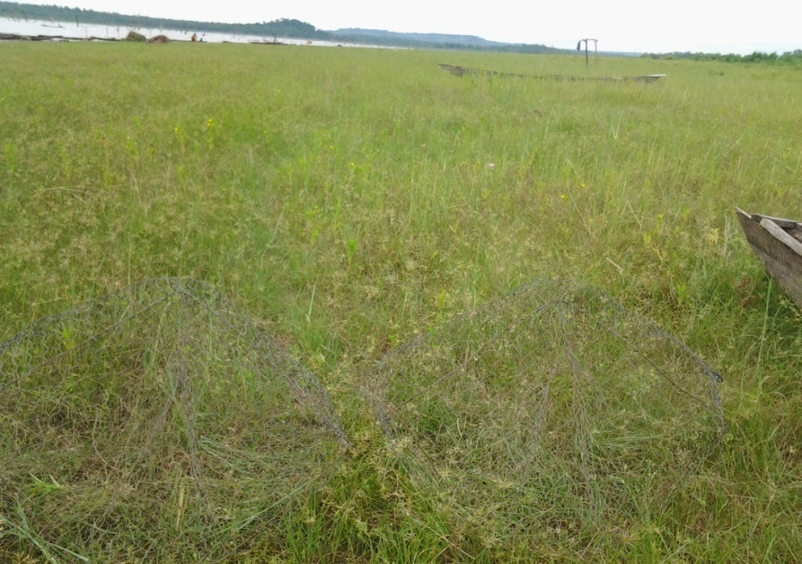

**Plate 1: Wire trap used in Apojola, Imala-odo and ibaro**

**Gura trap**

Gura trap is made from materials gotten from palm fronds or a particular forest material found in the area (Apojola and Imala-Odo) locally called (Ikan) and this (*Ikan*) is folded into conical shape and net of fine mesh size is weaved round it. The trap is provided with an opening at the top where bait is put to attract the fish, also two openings are provided at the bottom where fish enter in shoal. Gura trap was introduced to fishermen in Oyanlake by the Togolese,this is peculiar to Imala-Odo and Apojola fishing villages, though few fishermen also use it in other sampled villages.

,

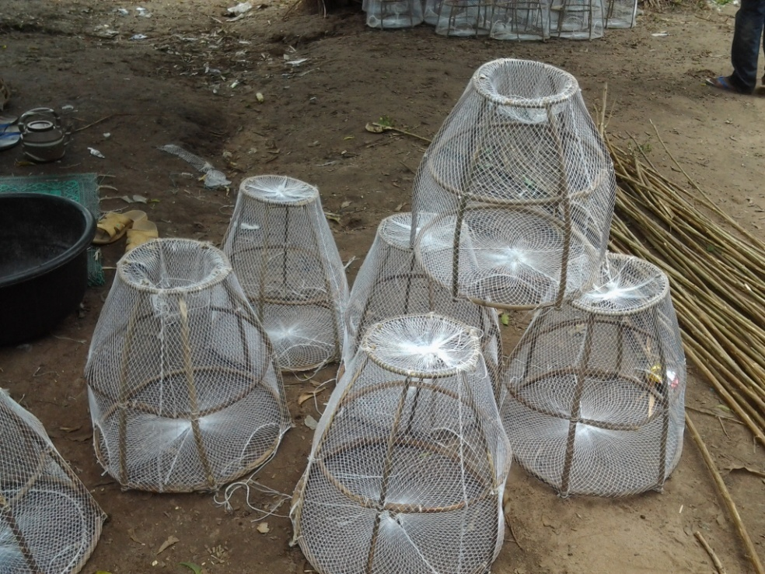

**Plate 2: Gura Trap in Apojola**

**Bamboo trap**

In this method, a bamboo pole is cut to contain 4 or more nodes, three of which are punctured to make the cavity continuous. A strong rope is then attached to the edge of the pole near the first punctured node, and with the help of this, the bamboo is lowered into the bottom of the water. The rope is pulled to bring the bamboo up and the fishes in them poured out.Fishing with bamboo is common in all the fishing villages sampled. It is common to all the sampled villages and used in all season.

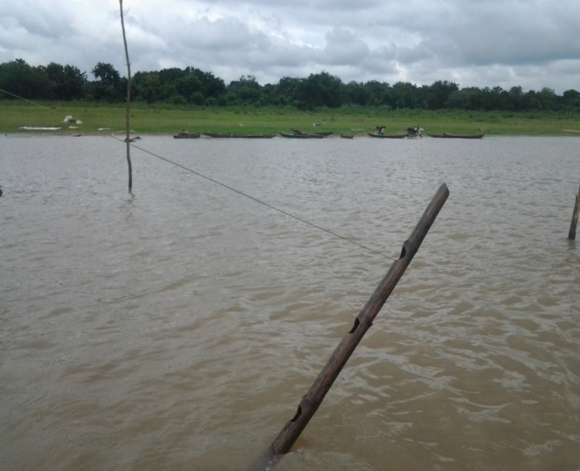

**Plate 3: Bamboo Trap Lifted from the water**

The modern methods found among fisher are cast net and gill net, though few of the fishermen are able to afford this.

**Cast net**

Cast net is pyramidal in shape with lead attached round the circumference and a long rope to the apex. With the aid of the rope, the net is thrown into water and with the aid of the leads, it sinks to the middle of the water.

This is the method of catching fish using a specially constructed net ‘cast’ or ‘thrown’ net. The net is pyramidal in shape with lead attached round the circumference and a long rope to the apex. With the aid of the rope, the net is thrown into water and with the aid of the lead, it sinks to the middle of the water and the net is brought out of the water after few seconds and the fish caught are alive. Fishes susceptible to this method are mainly the surface and mid-water dwelling species. The net is thrown with the fishermen standing on the boat or on the shore.

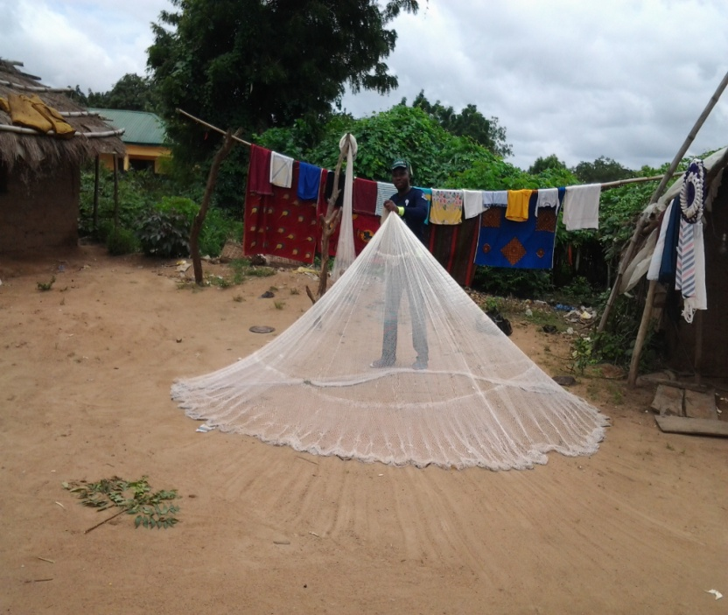

**Plate 4: Cast net in Apojola fishing village**

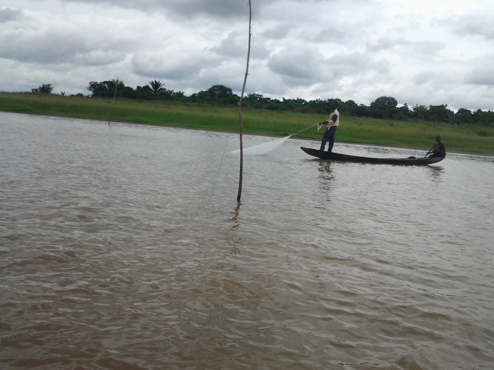

**Plate 5: Cast in use by fisherman in Apojola fishing village**

**Gill net**

Gill net is built into different mesh sizes depending on the sizes of fish desired. It can be set to catch surface or bottom dwelling species. In the first case, it is made to stay at the surface by attaching floats to the head rope. The float is made of rubber,or any other materials that can float on water.

Gill net is built into different mesh size depending on the sizes of the fish desired. It can be made and set to catch surface or bottom dwelling species. For surface species, it is made to stay at the surface by attaching floats to the head rope. The float is usually made of rubber or polyester materials, or any other floating materials.

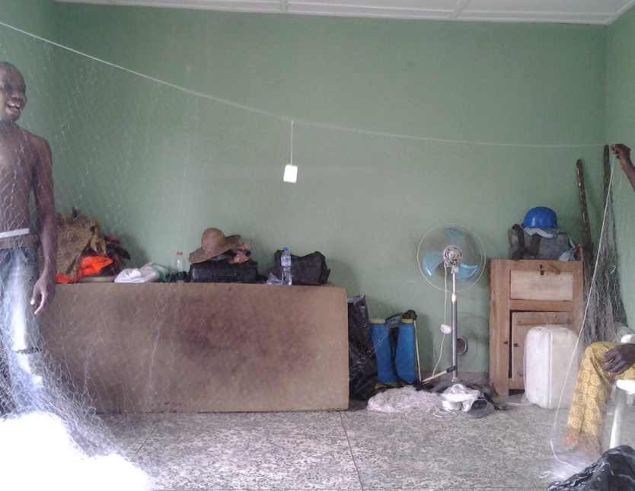

Plate 6: Gill net (2”) in Ibaro fishing village

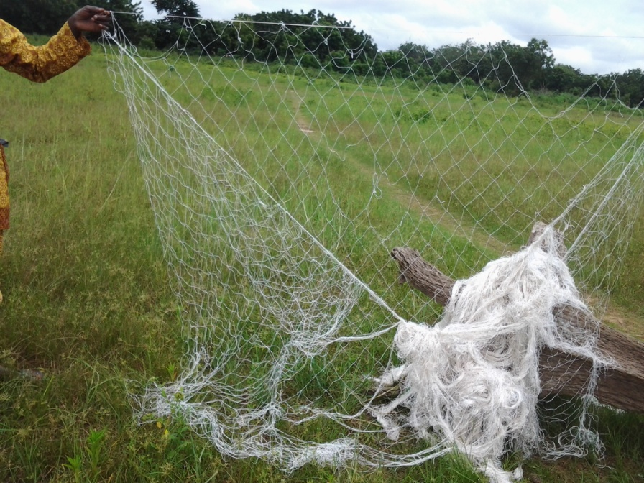

**Plate 7: Gill Net for catching Latesspp(5’’)**

**CHAPTER FIVE**

**5.0 DISCUSSION, SUMMARY, CONCLUSION, AND RECOMMENDATIONS**

**5.1 Discussion**

**Socio-economic Characteristics of fisher in Oyan Lake Area of Ogun state**

Almost all the fisher in the study locations were within the economically active age category of 16 and 60 years with the oldest fisher being 65 years. The mean age implies that the fishers were youthful and has been considered as highly productive to undergo tedious tasks associated with fishing (Bello, 2000 ;Olowosegun*et al*., 2004).

The findings of this study revealed that fishing is dominated by married persons and this aligns with the position of Ekong(2003) who pointed out that marriage in our society is highly cherished. This was further confirmed by the report ofOladoja*et al.*(2008) who asserted that marriage confers some level of responsibility and commitment on individuals who are married. The high percentage of married respondents were probably due to the fact that the respondents took fishing as a career and needed to generate additional income to sustain their living based on the responsibilities that come with marriage. The status of fisher especially married ones play greater role in fishing because the family members could be a useful source oflabour to assist in fishing operations such as gear construction, harvesting, and marketing of fish (Olaoye, 2010).

The mean house hold size (approximately 9 persons) indicated that the fishers had relatively large household sizes. The implication is that the large house size increases the number of labour that may be available in assisting the fishers. This goes in the same direction with the findings of Adegbite and Oluwalana, (2004) and Adegbite*et al.* (2008) that the larger the household size the more the likelihood of sustainable labour efficiency on farmer’s farm given the constant labour.

With regards to tribe, it was found that fishing was dominated by the Yorubas while other tribal groups within Nigeria such as Hausa, Agatu and Idoma and even some Togolese fishers. This implies that there is a high degree of social heterogeneity in the study areas.

The educational levels of the fishers indicated that the fishers either had lower educational attainment or no formal education at all, although some had up to secondary and tertiary levels of education. Education has been seen as a variable that widensome mental horizon, influences the totality of an individual and predisposed respondents to new innovations (Olaoye, 2010). The finding is similar to that of Okwoche *et a*l and Ogunwale (1998) that most fisher are either illiterates or semi-illiterates most of whom dropped out of formal school system. .

It was also found that majority of the fishers were practiced Islam or Christianity while very few proportion practiced the traditional religion. It was also found that some of the fishers engaged in other occupations apart from fishing. Occupation remains valid in our society as people have one or two things they engaged in which gives them sense of satisfaction and belonging in the society. Apart from fishing, other activities that generate income for the respondents were farming, petty trading, char coal production to mention a few in the study area.Thisagrees with the position of Ellis (2000) who observed that farming on its own is rarely sufficient for household needs in rural African settings.

The mean fishing experience of thefishersindicated that they have had sufficiently long number of years in fishing. The common view of the role of experience in fishing comes from the fact that it enables heads of household to have information on fishing ground, where fish go and span, and water currents. Earlier studies by Bartese and Coelli, (1995) on significance of improving the productivity of small- scale fishing households showed that experience in fishing could also enhance the ability to manoeuvre or handle gears effectively.

This study revealed that majority of the fishers was members of cooperative societies. Cooperative society is a social participation that helps farmers to pool their resources in order to have access to fisheries inputs and to have insights in their fishing issues. Membership of cooperatives is considered a factor that influences the adoption of improved fisheries technologies and poverty alleviation (Olaoye, 2010). Hence, being a member of association group could create peer pressure for fishermen to adopt new modern facilities. This is in line with Akinbile (1998) who observed that groups ensure that members derive benefits from the groups in which they cannot derive individually if they were acting alone.

The income realized per trip could be judged to be low and the low income generated by fishers indicated that the methods of operation engaged in by them were low as they could not afford modern facilities to enable them increase their level of production. Previous studies revealed that higher income had an influence on producers’ decision to adopt new technology (Olaoye, 2010).

**Identification and description of fishing gear used by fisher in Oyan Lake, Ogun State**

High cost of modern fishing gears and high cost of fuel used by the modern vessels and gears are major problem facing fishermen in Oyanlake. Nevertheless, fishers have acquired an amazing and detailed traditional knowledge of fish production. They therefore devised other means by making use of the traditional fishing gears and methods.

A total of 13 different gear types were identified in the community and the commonest ones used by fishers at the study area were *gura*trap, cast net (*Birigi*), gill net, and wire trap. The other gears included hooks and line, hand net, bamboo trap and fishing with basket. The most commonly used indigenous methods include bamboo traps, fishing with basket. Gura trap is the most important gear type used by the fishers. The cast net and gill nets fishing gears were used by few fishers. Most of the fishers combined the use of two or more fishing gears. For instance, a fisherman could own one gill net, gura trap bamboo trap, one cast net, one set of hook and line as well as some traps (wire) and any of them could be used anytime the fisher want. This may be as a result of fishing patterns (mixed fisheries) of the region; it is also a reflection of the flexibility in nature utilization and lack of rigid fishing regulations. As it has been reported by Tagago*et al.* (2011), different gears were used for targeting fish because of habitat changes. According to du Feu*et al.* (1997) and Bankole (2003), fishers use different kind of fishing gear because of seasonal variations in species availability. Whilst the present study gave a static description of a fishery in the dry season, it is apparent from other publications that fishers in Lake Kainji measured seasonal variation and fish species as their main reasons for switching fishing gear (du Feu*et al.*, 1997; Agbelege*et al.*, 2003; Bankole*et al.*, 2003).

Gillnet is ranked as the most important and the most used fishing gear among the fishers. The dominance of gill net followed by cast net can be traced back to the mid 70‟s as it has been earlier reported by Seisay, (1998). Gill nets are widely used in artisanal fisheries in developing countries because they are efficient, relatively inexpensive and capable of catching higher amount of economically valuable fish than other artisanal gears.

Individual fisher claimed that gill nets are more efficient, followed by cast net and hook and line respectively. Cast net and hook and line had quite similar trends among the fishers: the usage of these gears is very close. Unlike gill nets, trap made lower contribution to fishers’ catch, but fishers clarified that they got good quality catch from the traps. Fishing with spear and use of obnoxious fishing were not found among the fishers probably because their usage was banned in theOyan Lake.

Fishing with bamboo is an ancient method of fishing which is common in Oyan Lake. In this method, a bamboo pole is cut to contain nodes which are punctured to make the cavity continuous. A strong pole is then attached to the edge of the pole near the first punctured node, and with the aid of this, the bamboo is lowered into the bottom of the water. The rope is pulled to bring the bamboo up and the fishes in them are poured into a container. Bamboos are used by a single fisher, and usually checked on daily basis. *Clariasspecies* are commonly caught using this method; fishermen described this method as very cheap and productive.

The idea of wire trap was copied from the wire used to catch forest animals. The wire is made into a triangular shape with an opening without exit; two poles are used to hold the trap in water to avoid falling which may allow caught fishes to escape.Hand net consists of woven material with a wire ring forming the frame and the handle. It is used to scoop fish from water surface and from the shores; it is also use to scoop fish from a boat. It is mostly used by women folks and children and the fish caught are usually small. This method is mostly use among women and children folks in all fishing villages (Field survey, 2017).

Hooks are locally made from iron by the black-smiths or iron-bender. Imported ones are made of iron, aluminum or silver available but costlier and are said to be more effective in fishing.A hook consists of the eye, the shank and the ‘U’ part. The width of the ‘U’ part is the diameter of the hook; some hooks lack the eye in which case the twine has to be tied to the constricted part of the shank. Fish can be hooked in the jaws, gill, eyes,nostrils, throats or even stomach. This is commonly use among children in Apojola and Ibaro fishing villages. This method is common in Imala-Odo and Apojola which are the busies landing site were fishermen make use of (cast net), the method involves using some local food materials as baits to attract the fish, the local baits includes earthworm, small fishes, *eba* mixed with palm oil, bread, garri soaked in wateretc. These baits will be thrown into the water normally in the shallow part of the water and a long stick may be used to mark the area where these baits are thrown. The fisherman will wait for about an hour after throwing the baits in an interested area in the water body. He will ensure they(fishes) are eating the bait. In most instances, these baits are normally made to get to the bottom of the water so that the fish can have access to it undisturbed compare to when it floats and the fish easily get disturbed and escape.

After an hour period, the fisherman will use a throwing net to encircle the area where these baits are put. The net will capture those fishes that have gathered in that area to eat the bait.This method is normally carried out in an open water body where the water is not muddy so that the fish can see the bait clearly and swim to eat it. Also, this method is carried out in open water so that canoe which the fisherman uses can move freely on water without hindrance.The species of fish captured through this method includes *Tilapia spp*, *Chrisichthysnigodigitatus* (locally called *Obokun*).The modern methods found among fisher are cast net and gill net, though few of the fishermen are able to afford this (Olaniyan, 2015).

**S**pecies of fish commonly caught in the communities include Tilapia spp*, Chrysichthysnigrodigitatus, Latesniloticus, Heterotisniloticus,Clariasspp, Aletesspp.Chinnaobcura* was the only species of fish the respondents could identify as not being available in the water body as before and this occurs as a result of destruction of habitat in the course of expanding the lake also as a result of Overfishing. New species of fish in Oyan Lake is Red Tilapia which was introduced into the water by companies that are practicing cage culture on the water such as Premium aquaculture, Durante etc. This fish escaped into the water in the process of harvesting.

Fisher’ perception indicated that the fishers were favorably disposed to the use of indigenous fishing methods. This implied that the fishers were satisfied with their current use of indigenous methods for fishing. Respondents believed that the use of indigenous method pose no health hazard to fish neither does it lead to pollution of water body. This is contradictory to the position of Olaniyan (2015) who said the crude techniques of fishing had not only brought a serious decline into commercial fisheries, but has also introduced hazards of various magnitudes to the consumers and the entire aquatic environment.

Awareness of fisheries extension service was high among the fishers. Also, while extension agents were the major source of awareness, the fishers also made use of radio, television and print media. This is in line with the work of Bolorunduro*et al* (1996) that majority of the fishermen were aware of extension agents. The low percentage of respondents who had their awareness through print media can be attributed to their low level of education which indicated that only 4.2% had tertiary education.

Frequency of visitation by extension agents was 65% and 25% quarterly and fortnightly respectively. Extension agents used group method in disseminating information to the fishermen when visited.According to field survey, the fisherhas not been introduced to any modern method of fishing and this has led to continuation of the indigenous method of fishing.

**5.2 Summary**

This research was carried out to investigate the indigenous fishing methods used among fisher in Oyan Lake by collecting relevant qualitative and quantitative data from fishers in four purposively selected villages. The villages (Ibaro, Imala-Odo, Apojola and Abule-Titun) were selected based on their nearness to Oyan Lake and the fishers’ use of indigenous fishing methods. Quantitative data were obtained from 120 fishers while qualitative data were obtained from 20 key informants through in-depth interview. The specific objectives were to describe the socio-economic characteristics of the fishers, identified and described the indigenous fishing gears used in fishing communities around Oyan Lake, determine the fishers’ perception of indigenous fishing methods, identify common fish species caught in the communities and identify the source of extension services available to fishers. The detailed analyses of the results are summarized below.

The study sought for the socio-economic characteristics of the respondents, it reveals that majority of the respondents (89.2%) were male and were in their active age 31-40 years and were married while 9.2% were single, and 1.6% widowed. The information about the level of education shows that 59.2% had primary education, also the study reveals that majority of the respondents 55% were Muslim.

The indigenous fishing methods identified in the course of the study includes; Fishing with bamboo, hooks and lines, traps, use of basket lift nets, wire trap, and Gura trap. The modern methods found among the respondents were use of Cast net and Gill nets.Commonspeceies caught includes *Tilapia spp, Chrysichthynigrodigitatus, Latesniloticus, Heterotisniloticus* and the newly introduced species is Red tilapia while *Chinnaobcura* is almost going into extinction in the water body.

The study reveals that almost all the fishers had a favorable perception about the use of indigenous method of fishing while only (0,8%) had an unfavorable perception.

The study also showed that majority of the respondents were aware of fisheries extension agencies, and that the respondents love to use the indigenous methods of fishing because of their simplicity, cost-effectiveness and ease of maintenance and repair.

**5.3 Conclusion**

Indigenous fishing methods are cheaper to acquire, simpler to use and repair but at the same time it made fishing a time-consuming ventures with littleor no harvest to show for the time wasted, also it can lead to pollution of water which is source of drinking water to majority, though it is efficient and profitable. However, the fisher can still pull their resources together to acquire modern technology to increase their fish production and improve their standard of living. Introduction of modern fishing technique has not only boasted fish supply, but hasbrought appreciable positive effects on proteins consumption, alsopreventing lot of health hazards associated with the consumption ofpoisoned fishes using a modern method is a good and reliable avenuefor improving the nation’s economy a good source of job creation.

**5.4 Recommendations**

The following recommendations were made from the observations and analysis of the data obtained in this study

1. Government should educate fisher on the need to improve their method of fishing in order to increase their level of fish production
2. The fishers should be encouraged on the need for education in order to improve their business
3. Capital should be provided to fishermen in form of soft loan to local and commercial fishermen to procure these equipment’s at affordable prices.
4. Government should enlighten and encourage fisher through extension agent on how to use modern method of fishing.
5. The tariffs on imported modern fishing equipment should be reduced to make it affordable for fishers
6. Government should encourage the indigenous fishers since these methods is accessible and profitable to both male and female as well as general Nigerian population fish demand.
7. Organizing workshops and seminars for fish farmers in order to up-date their knowledge on modern fisheries.

These project work also help to acquaint the local fish farmers with the benefits accruable from the use of modern fishing techniques and the hazards associated with the continued use of indigenous methods.

**REFERENCES**

Abdul, W. O. (2005). Fishing Gear Design and Production lectures. In: Fishing Methods in Nigeria. Federal University of Agriculture, Abeokuta, Nigeria. 20pp.

Adegbite, D.A., Oloruntoba, A.O. and Olaoye, O.J. (2008). Performance assessment of Ogun State Agricultural and Multi-purpose credit Agency (OSAMCA) in credit delivery and operation (2004-2006). *Journal of sustainable Development in Africa*, 10(3): 127-153.

Adegbite, D.A.andOluwalana, E.O. (2004). “Resolving loan scheme as a poverty alleviation strategy: A case study of women group in UNAAB extension village” *FAMAN Journal*, 7(2): 18-32 pp.

Agbelege, O. O. Raji., A.andMofio, M. M. (2003). fishing gear survey of Lake Chad. In: Eyo , A. A. and Ajao, E. E. (Eds.). Proceedings of the 16th Annual Conference of the Fisheries Society of Nigeria (FISON). 87-98 pp.

Ajana, A. M. (2002). Overview of highlight and problems of fisheries extension in Nigerian Agriculture. *Nigeria’s Pioneer Agriculture News Reporting and Trade Promotion Magazine*, 4(1), 27-32.

Ajana. A. M., 1980. Fishery of the mangrove, in the Lagos area, Nigeria. Aquaculture, 21: 129-137 pp.

Akegbejo-Samsons, Y. (1997): Introduction to aquaculture and fisheries management in

Akeredolu, M.O. (1990). Constraints to technology transfer in artisanal fisheries. Unpublished Ph.D. thesis Dept. of Agricultural Extension, University of Ibadan.

Akinbile, L.A. (1998). Group formation and group dynamics. Paper presented at NAERKS workshop on extension communication techniques. Moor Plantation, Ibadan, 11pp.

Ambrose, E.E. and Udolisa, R.E.K. and Solarin, B.B. and Lebo, P.E. (2001). Technological status and development prospects of small-scale fishing crafts in Nigerian coastal water. In: 14th Annual Conference of the Fisheries Society of Nigeria (FISON), 19-23 January 1998, Ibadan, Nigeria, pp. 139-144.

Annune, P. A. and Ogbe, F.G (2000). “Problems of capture fisheries in Benue State”, 15th annual conference of Fisheries Society of Nigeria held at Jos, Plateau State 19th – 24th March 2000. pp 49-52 pp.

Areola, F. O. (2007). Fish marketing and export potentials of fish and fisheries products of Nigeria. A lecture delivered at educative and informative aqua-culture workshop and aqua-exhibitions tagged: sustainable fisheries livelihood, management and food security in Nigeria. 23pp.

Ayoola,. S.O.Kuton,. MP. (2009). Seasonal Variations in Fish abundance andphysicochemical parameters of Lagos Lagoon Nigeria. African.*Journal of Environmental Science and Technology* 3: 149-156 pp.

Bankole N.O., Raji I.A., Adikwu O.A, Okwundu E.C., (2003). Fishing gear survey of Lake Alau, In: A.A. Eyo and E.A. Ajao (Eds), Proceedings of the 16th Annual Conference of the Fisheries Society of Nigeria (FISON). Maiduguri, 4th-9th November, 2001. 99-103 pp.

Battese, G.E. and Coelli, T.J. (1995) Frontier production functions, technical efficiency, panel data: With application to paddy framers in India. *Journal of productivity Analysis* 3: 153-169 pp.

Bello, M. O (200):”Categorization of potential adopters for organic based fertilizer among vegetable farmers in Ojo LGS State. B. Agric. Project University of Agriculture, Abeokuta.” 35 pp.

Bolorunduro, P. (1996). Livestock and fisheries production technology for women in Agriculture. In proceedings of the National trading workshop held of NAERLS, Consultation, Rome, Italy, pp: 65-68.

Central Bank of Nigeria (CBN) (2012). Central Bank of Nigeria Annual Report and Statement of Accounts for year ended 31st December, 2012.

Clement, A. R. (2013). Vulnerability of Fisheries Livelihood in the Coastal Area of the Niger Delta Region of Nigeria. World Journal of Fish and Marine Sciences, Vol. 5, NO 2: ISSN 2078- 4589, pp 152- 158.

Coul, R. J. (1993). World fisheries resources. Routledge Public Company. London.

Cunninghum, D and Withmarsh, D. (1980) Fishing efforts and fishing policy. *Marine Policy* 5: 309-316 pp.

Ekong, E.E. (2003). An introduction to rural sociology (2nd edition).Uyo. Nigeria dove educational publishers. 259-285pp.

Ellis, F. (2000). Rural livelihood, diversify in developing countries: evidence and policy. *Environment*, 2(1): 298-302.

Emmanuel, B. E. (2010). Fishing crafts characteristics and preservation techniques in Lekki lagoon, Nigeria. Journal of American Science; 6 (1): pp 105-110.

Federal Department of Fisheries (2003). Presentation on the Fisheries sub –sector at the Presidential forum Lagos. Fisheries Society of Nigeria 34-56.

Federal Department of Fisheries. (2005). Fisheries Department in Nigeria; the current challenges, Paper presented by the Honourable of state of agriculture to the Fisheries Society of Nigeria (FISON), Lagos state. 145 pp.

Federal Department of Fisheries. (2009). Fisheries Department in Nigeria; the current challenges, Paper presented by the Honourable of state of agriculture to the Fisheries Society of Nigeria (FISON), Lagos State. 23 pp.

Federal Department of Fisheries.(2008). Fisheries Statistics of Nigeria.Fourth edition, 1995 – 2007, Nigeria 48 pp.

Fisheries biology) for the evaluation of management alternatives. Final report NOAA/NMFS, pp 96

Food and Agricultural Organisation (1993). “Experiences in Community Based Management”: Discussion Guide, FAO Fisheries Report 2 (474) Rome pp. 552-555.

Food and Agricultural Organisation. (2000). FAO Fishery Department Country Profile.Nigeria FID/CP/NIR. Rev. 4. March 2000. 11 pp.

Food and Agricultural Organisation. (2012). The state of World Fisheries and Aquaculture 2012, Rome. 209 pp.

Food and Agricultural organization (1993). B.P Satia. “Ten years of integrated Development of Artisanal Fisheries in West Africa.” Technical Report No. 50 (FAO 1993).

Food and Agricultural Organization (2002).“Promoting the contribution of sustainable livelihoods approach and the code of conducts for responsible fisheries in poverty alleviation.” FAO Fisheries Report No. 678 (Sustainable Livelihoods Programme, 2002)

Gorden, C. E. (1993). Engineering, Economics and Fisheries Management. Buckland Foundation Books.

Ibrahim, B. U. Auta, J. Balogun, J. K. (2009). A survey of the Artisanal Fisheries of Kontagora Reservoir, Niger State, Nigeria. Bayero Journal of Pure and Applied Sciences, Vol.2, NO: 1: pp 47-51.

Idowu, A. A., Olaoye, O. J., Ifegbesan, A., Abdul, W. O. and Olawale, O. B. (2012). Evaluation of fishermen transactional sex for fish marketing in coastal areas of Ogun Waterside Local Government Area, Ogun State, Nigeria. *Global Journal of Science Frontier Research: Agricultureand Biology*, 12(1), 42 – 53.

Ikenweiwe, N. B., Otubusin, S. O., Akinwale, M. M. and Osofero, S. A. (2007). A comparison of the composition and abundance of fish species caught with experimental gill net with that of artisanal fishermen at Oyan Lake, South west, Nigeria. *European Journal of Scientific Research*, 6(3): 336 – 346.

Ita, E. O. and Sado, E. K. (1987), “Inventory Survey of Nigeria Inland Waters and their Fishery Resources with Special, Reference to Ponds, Lakes, Reservoir and Major Rivers: Surface Area Survey and Potential Yield, Estimates”. Kainji Lake Research Institute, New Bussa.

Ita, E. O. and Sado, E. K. (1987). “Inventory survey of Nigeria inland waters and their fishery resources with special reference to ponds, lakes, reservoir and major rivers: Surface area survey and potential yield, estimates”. Kainji Lake Research Institute, New Bussa.

Leone marine fisheries. African rural employment/economic workingpaper 18.

Mustapha M. K. (2013). Potential Impacts of Climate Change on Artisanal Fisheries of Nigeria. J Earth Sci Climate Change 4: 130. doi:10.4172/2157-7617.1000130.

National institute for freshwater fisheries Research (NIFFR), 2002. National surveys of fishing gears and crafts on Nigerian inland water bodies. NIFFR occasional paper No.4.ix, pp 4. ISSN 0794-2451, ISBN 978-177-051-1.

Nigeria. Abeokuta. Good education Publishers, 87pp.

Okwoche, V.A., Voh, J.P. and Ogunwale, S.A, (1998). Socio-economic characteristics influencing adoption behavior of women co-operators and non – cooperators in Oju Local Government area of Benue State. *Journal of Agricultural Extension* 2: 31-38pp.

Oladoja., M. A., Adedoyin, S. E. and Adeokun, O. A. 2008.Training needs of fisher on fishing technologies. *Journal of Food Agriculture and EnvironmentScience and Technology.*Vol. 6: (1) 281 – 290 pp.

Olaniyan, R.F. (2015). Fishing methods and their implications for a sustainable environment. *Fish Aquatic Journal* 6: 139 pp.

Olaoye, O.J. (2010). Dynamics of the adoption process of improved fisheries technologies in Lagos and Ogun States, Nigeria. A ph.D Thesis in the Department of Aquaculture and Fisheries Management, University of Agriculture Abeokuta, Ogun State, Nigeria. .337 pp.

Olowosegun, T., Sanni, A.O., Sule, A.M. and Bwala, R.L. (2004). Contribution of women to fisheries development in Kainji Lake Basin, in 2004 FISON Conference proceedings, 91-97 pp.

Oota, L. (2012). Is Nigeria Committed to Fish Production. Accessed online 20th October 2012 from <http://blueprintng.com/2012/07/is-nigeria-committed-to-fish-production>

Orensanz, J. M. Parma, A. M. Jerez, G. Barahona, N. Montecinos, M. Elias, I (2005). What are the key Elements for the Sustainability of “S-Fisheries”? Bulletin of Marine Science, Vol. 76, NO. 2. 527-556 pp.

Otubusin, S.O., 2011. Inaugural lecture: Fish! Fish !!Fish!!!. Department of Aquaculture and Fihery Management, University of Agriculture, Abeokuta, Nigeria, pp: 45-55

Oyakhilomen, O. and Zibah, R. G. (2013). Fishery Production and Economic Growth in Nigeria: Pathway for Sustainable Economic Development. Journal of Sustainable Development in Africa, Vol.15, NO. 2, ISSN: 1520-5509. pp 11.

Sagua, .V.O. (1976). Economic analysis of alternative strategies for the development of Sierra

Seisay, M. D. B. (1998). The cast net fishery, Kainji Lake, Nigeria, 1970-1997. Nigerian- German (GTZ) Kainji Lake fisheries promotion project Technical Report Series 12. ISSN: 1119- 1449: pp 28pp.

Seisay, M. D. B. duFeu, T. A., and Abayomi, O. S. (1997). Fishing gear survey, Kainji Lake, Northern Nigeria, 1996. Nigeria German Kainji Lake Promotion Technical Report No. 6-20 pp.

Shimang, G.N., 2005. Fisheries development in Nigeria, problems and prospects. The Federal Director of Fisheries, The Federal Ministry of Agriculture and Rural Development, Abuja.

Solarin, B. B. (1998). The hydrobiology, fishes and fisheries of the Lagos lagoon, Nigeria. Ph.D. Thesis. University of Lagos. pp235.

Soyinka,. O.O, Kassem,. A.O. (2008). Seasonal variation in the distribution: Fish species diversity of a tropical Lagoon in South-West Nigeria*. Journal of Fisheries and Aquatic Science* 3: 375-383 pp.

Tagago, T. A. and Ahmed, Y. B. (2011). Fishing gear survey of Tatabu floodplain, In: R.J. Koko and A.M. Orire (Eds), Proceedings of the 26th Annual Conference of the Fisheries Society of Nigeria (FISON). 28th November-2nd December, Minna, Niger State, Nigeria. 109-116 pp.

Tijani, B.(2011). Federal Ministry of Agriculture and Rural Development Action Plan Towards the Attainment of a Sustainable Agricultural Transformation in Nigeria. Being a Lead Paper delivered at the World Food Day Seminar, Agricultural show ground KeffiRoad, Abuja, Nigeria. pp. 1 – 10.

Tobor, J. G. (1990): “The fishing industry in Nigeria”: Status and potential self-sufficiency in fish production. National Institute for Oceanography and Marine Research (NIOMR) Victoria island, Lagos, Technical paper No. 54 pp 2-10

Tsadu, S.M., Ojutiku, R.O and Anyawale, A.V. (2006). A survey of fungal contamination of some fish species from Tagwai Daru, Minna, Niger State, Nigeria. Jour. Of Tropical Biosciences. 6: pp 1-5.

Udolisa R. E. K., Solarin B.B., Lebo P., Ambrose E.E., (1994). A catalogue of small scale fishing gear in Nigeria. RAFR Publication RAFR/041/F1/94/02. pp 142.

United States Agency for International Development, (2010). Best Management Practices for Fish Farmers in Nigeria. USAID Markets Programme – Nigeria. 1 – 38 pp.

Williams, J. N. (1995). “Economic analysis of crayfish production, processing and marketing amongst rural women in Rivers State,” Nigeria. Unpublished MSc Thesis Department of Agricultural Economics University of Nigeria, Nsukka, Nigeria.

Williams, S.B. (1987). Economic status of artisanal fishermen in Ondo and Ogun States, Nigeria. *Ife Journal of Agriculture*. 9(1&2): 101-112.

**Appendix**

**FEDERAL UNIVERSITY OF AGRICULRUTE, ABEOKUTA**

**COLLEGE OF ENVIRONMENTAL RESOURCES MANAGEMENT**

**DEPARTMENT OF AQUACULTURE AND FISHERIES MANAGEMENT**

**TOPIC: INVESTIGATION OF THE INDIGENOUS FISHING METHODS USED AMONG FISHER IN OYAN LAKE, OGUN STATE, NIGERIA**

Dear Respondent,

I am a final year student from the Department of Aquaculture and Fisheries Management, Federal University of Agriculture, Abeokuta. This questionnaire is to get information from you on the above topic. Please your co-operation is highly needed by responding to all questions asked to the best of your knowledge. I assure you that all information given will be treated confidentially and used for research purpose only.

Thanks.

**ADEYEMI, MARY O.**

INSTRUCTION: Please tick ( ) or fill in the gap as appropriate.

**SECTION A: SOCIO- ECONOMIC CHARACTERISTICS OF THE RESPONDENT**

1. Age of the respondent ………………years
2. Sex: (a) Male { } ( b) Female{ }
3. Marital status (a) Single { } (b) Married { } (c) Divorced { } (d) widow { }
4. Household size …………….persons
5. Tribe: (a) Igbo{ } (b) Yoruba { } (c) Hausa{ }
6. Level of education (a) No formal education [ ] (b) Primary education [] (c) Secondary education[ ] (d) tertiary education [ ]
7. Year spent in Schooling……………………………………………………………Year
8. Religion (a) Christianity [ ] (b) Islam [ ] (c) Traditional [ ]
9. Fishing experience ………………years
10. What is your primary occupation? …………………….
11. What is your secondary occupation?…………………….
12. What is your reason for involving in fishery business? .........................................................
13. Do you belong to any co-operative society? (a) yes [ ] (b) No [ ]
14. Do you belong to fishers’ association? (a) yes [ ] (b) No [ ]
15. Number of fishes caught per fishing trip …………………………… (Number), …………….. dozens
16. How much do you realize per fishing trip ………………………….
17. How many fishing trips do you go per week ……………………….

**Section B: Indigenous fishing methods**

1. Kindly indicate the fishing methods that were used in the olden days in this community. Also, indicate if the methods are still in use today. Please indicate the fishing methods that were used but not listed below.

|  |  |  |  |  |
| --- | --- | --- | --- | --- |
| **s/no** | **Fishing methods** | **Used in olden days** | **Still in use** | **Not in use** |
| 1 | Hand picking |  |  |  |
| 2 | Dewatering |  |  |  |
| 3 | Fishing with bamboo |  |  |  |
| 4 | Fishing with hook and line |  |  |  |
| 5 | Traps |  |  |  |
| 6 | Fishing with cutlass |  |  |  |
| 7 | Obnoxious method (e.g poison) |  |  |  |
| 8 | Fishing with spears |  |  |  |
| 9 | Basket trap “*Ebiri*” |  |  |  |
| 10 |  |  |  |  |
| 11 |  |  |  |  |
| 12 |  |  |  |  |
| 13 |  |  |  |  |
| 14 |  |  |  |  |
| 15 |  |  |  |  |

**Section C: Description of the indigenous fishing methods**

1. Please describe the indigenous fishing methods detailing how it is made, when to use, quantity of fish it can catch at once, how many people can operate it, etc (Please take picture if available)

Fishing gear 1: -----------------------------------------------------------------------------------------------------------------------------------------------------------------------------------------------------------------------------------------------------------------------------------------------------------------------------------------------------------------------------------------------------------------------------------------------------------------------------------------------------------------------------------------------------------------------------------------------------------------------------------------------------------------------------------------------

Fishing gear 2: -----------------------------------------------------------------------------------------------------------------------------------------------------------------------------------------------------------------------------------------------------------------------------------------------------------------------------------------------------------------------------------------------------------------------------------------------------------------------------------------------------------------------------------------------------------------------------------------------------------------------------------------------------------------------------------------------

Fishing gear 3: -----------------------------------------------------------------------------------------------------------------------------------------------------------------------------------------------------------------------------------------------------------------------------------------------------------------------------------------------------------------------------------------------------------------------------------------------------------------------------------------------------------------------------------------------------------------------------------------------------------------------------------------------------------------------------------------------

Fishing gear 4: -----------------------------------------------------------------------------------------------------------------------------------------------------------------------------------------------------------------------------------------------------------------------------------------------------------------------------------------------------------------------------------------------------------------------------------------------------------------------------------------------------------------------------------------------------------------------------------------------------------------------------------------------------------------------------------------------

Fishing gear 5: -----------------------------------------------------------------------------------------------------------------------------------------------------------------------------------------------------------------------------------------------------------------------------------------------------------------------------------------------------------------------------------------------------------------------------------------------------------------------------------------------------------------------------------------------------------------------------------------------------------------------------------------------------------------------------------------------

**SECTION D: FISH SPECIES CAUGHT**

1. Are there fish species that were highly caught in the olden days that are no longer found nowadays? a) Yes b) No
2. If yes, please list some of them: ------------------, ------------------------------ --------------------------------

----------------------------------------------------, ---------------------------------------- ------------------------------------------

22. Why do you think those fish species were no longer available? ---------------------------------------------------------------------------------------------------------------------------------------------------------------------------------------------------------------------------------------------------------------------------------------------------------------------------------------------------------------------------------------------------------------------------------------------------------------------------

23. Are there new fish species that were not available in the olden days? a) Yes b) No

24. If yes, please provide a list of some of them: --------------------------------------------- ---------------------

------------------------------------------------ ----------------------------------------- ------------------------------------------

25. Kindly list some of the fish species commonly caught in this community ………………………., ………….

-------------------------, -----------------------, --------------------------------, ----------------------------------, ----------------

**SECTION E: PERCEPTION OF USE OF INDIGENOUS FISHING METHODS ON SUSTAINABLE FISH SUPPLY**

26. Kindly indicate your level of agreement and/or disagreement with the following perception statements from strongly Agreed to Strongly disagreed

|  |  |  |  |  |  |
| --- | --- | --- | --- | --- | --- |
| **C** | **Strongly Agree** | **Agree** | **Undecided** | **Disagree** | **Strongly Disagree** |
| 1.The use of indigenous fishing methods led to indiscriminate fishing of fishes irrespective of size and age |  |  |  |  |  |
| 2.Indigenous fishing methods are simpler to use |  |  |  |  |  |
| 3.Indigenous fishing methods lead to pollution of water bodies |  |  |  |  |  |
| 4. The use of indigenous methods had led to the depletion of aquatic organisms in the lagoons |  |  |  |  |  |
| 5. Indigenous methods do not ensure the continuous capture of fish |  |  |  |  |  |
| 6.The fishing output from the indigenous methods are higher than those obtained from the modern fishing techniques |  |  |  |  |  |
| 7.Indigenous fishing methods are cheaper to acquire |  |  |  |  |  |
| 8.Indigenous fishing methods are better for capturing specific fish size and age |  |  |  |  |  |
| 9.The use of Indigenous fishing methods poses no health hazards to the fishermen |  |  |  |  |  |
| 10. The indigenous fishing methods are easy to maintain and repair |  |  |  |  |  |

**SECTION F: FISHER’ CONTACT WITH FISHERIES EXTENSION SERVICE**

27. Are you aware of fisheries extension services? a) Yes b) No

28. If yes, how? a) Through visits by extension agents b) Through fellow fishermen c) On radio d) On television e) Print media f) Others (specify)-------------------------------------------------------------------------------------------------------------------------------------------

29. Have you been visited by fisheries extension agents? a) Yes b) No

30. If yes, when was the first time? (Please state the year) -------------------------------------------------

31. How often are you visited by fisheries extension agents? a) Fourthnightly b) Monthly c) Quarterly d) Twice a year e) Not regular

32. When visited, which methods were used by extension agents in disseminating fishery information to you? (a) Individual (b) Group (c) Mass media (d) Integrated

33. Have you been introduced to any modern fishing methods by the fisheries extension agents? a) Yes b) No

34. If yes, kindly list the fishing methods that were introduced to you. ------------------------------------, -----------------------------------------, --------------------------------------, --------------------------------------, ----------------------------------------------------, --------------------------------, ---------------------------------------, ------------------------------------

35. Were any of the listed modern fishing methods demonstrated to you? a) Yes b) No

36. If yes, which of the modern fishing methods? ------------------------, ------------------------------, ----------------

37. Are you currently using any of the modern fishing methods? a) Yes b) No

38. If yes, which of them? -----------------------------, -------------------------------, -------------------------, -------------

39. Has your use of any of the modern fishing methods led to your discontinuance of the indigenous fishing methods? a) Yes b) No

40. If yes, which of them? -----------------------------, -------------------------------, -------------------------, --------------